Student Name: Anirudh Kumar  
Email: akuma282@asu.edu  
Submission Date: November 24, 2022  
Class Name and Term: CSE548 Fall 2022

Project 4 : ML Algorithms based attacks

# Project Overview

An NSL-KDD dataset is used for this lab with the purpose of data pre – processing, training, and testing with Anaconda, TensorFlow and FNN, NSL-KDD dataset Is one of most common network traffic and attacks.

# Network Setup

below the initial set-up of the virtual infrastructure as I have configured it in VirtualBox for this VM – it is simply connected via NAT.

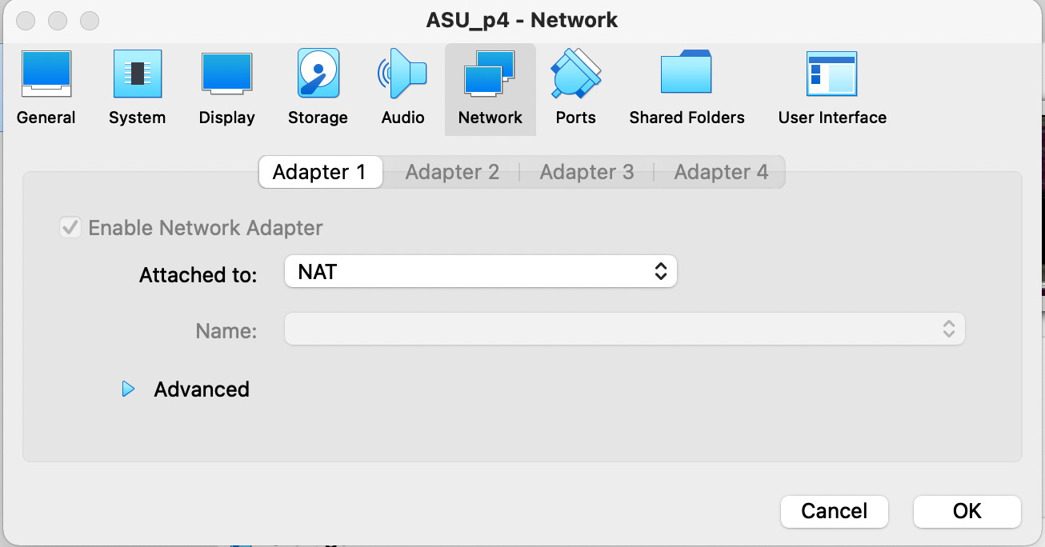

Figure - Bridged network setup in VirtualBox

# Software

For this first lab, the following software has been used:

* Ubuntu 18.04 LTS
* Python – <https://www.python.org/>
* Anaconda - <https://www.anaconda.com/>
* TensorFlow - <https://www.tensorflow.org/>
* NSL-KDD dataset - <https://www.unb.ca/cic/datasets/nsl.html>

# Project Description

In this assignment, I have executed the various labs assignments, obtaining the proofs that they have been successfully completed.

The first lab (CS-ML-00201) a supervised Machine Learning (ML) approach is proposed, where Feed-forward Neural Network (FNN) solutions are used. The dataset used as input, NSL-KDD, provides labeled normal network traffic and labeled attack network traffic. FNN will use the well-labeled data to build FNN-based data pattern to differentiate normal and abnormal network traffic. After training, we use similar data set with labeled data to validate the accuracy of the generate anomaly detection pattern.

## Run the provided fnn sample.py python program with different NSL-KDD datasets as the input, and compare their detection accuracy

I have created the Python code to allow using the different training data by just changing a couple of comments, as shown below:

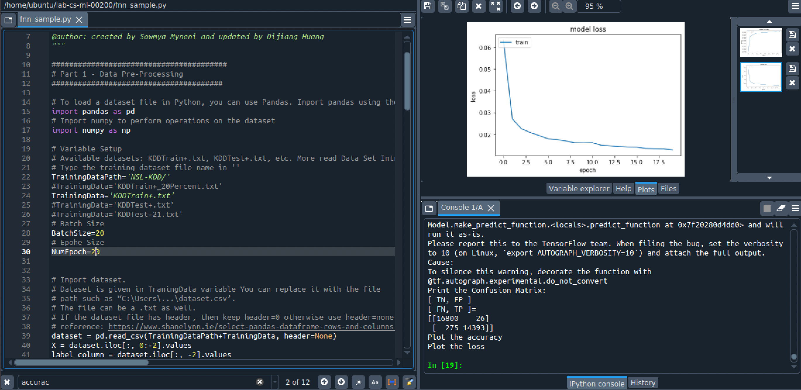

It is very easy in this way to collect the results and observe the differences from the various datasets. For instance, it is obvious to observe that accuracy increases with each epoch run:

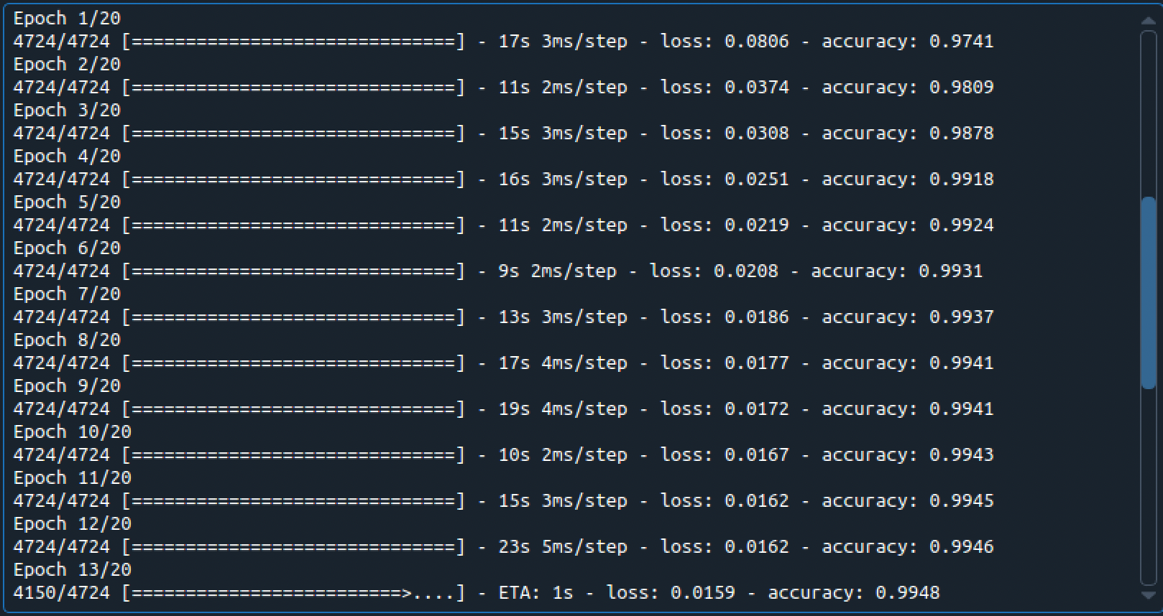

The followings are the results obtained by running the detection on the various datasets.

KDDTrain+: Loss 0.0221, Accuracy: 0.9912

Confusion Matrix: TN=16806, FP=20, FN=533, TP=14135

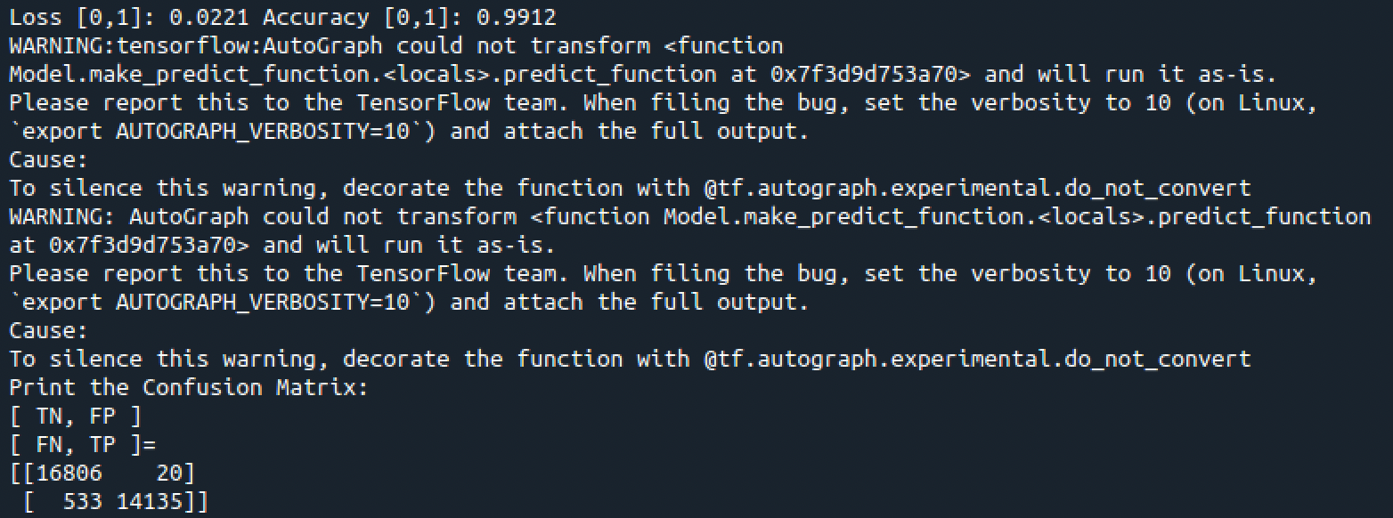

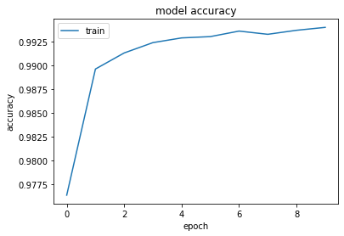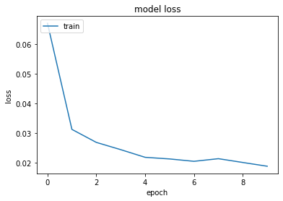

KDDTrain+20Percent: Loss 0.0319, Accuracy: 0.9835

Confusion Matrix: TN=3386, FP=1, FN=174, TP=2737

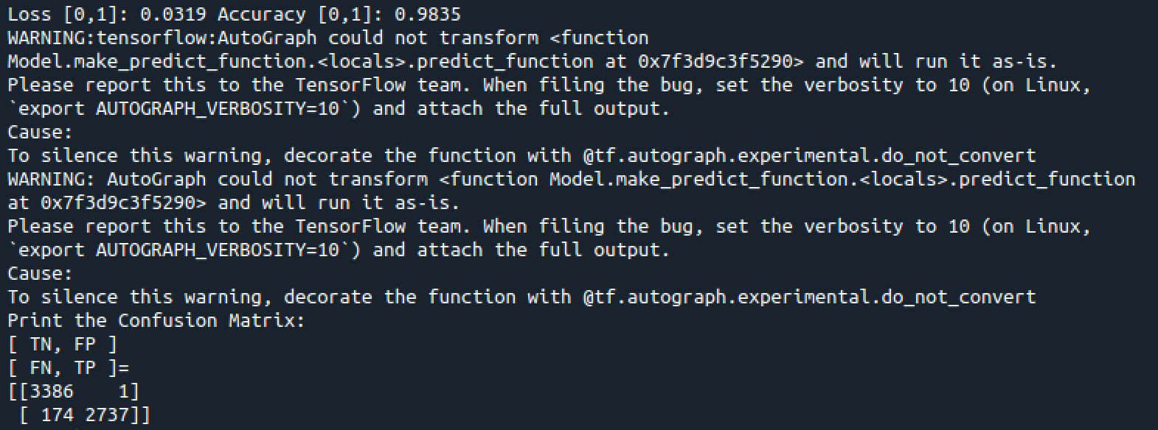



KDDTest+: Loss 0.0675, Accuracy: 0.9683

Confusion Matrix: TN=2486, FP=18, FN=356, TP=2776

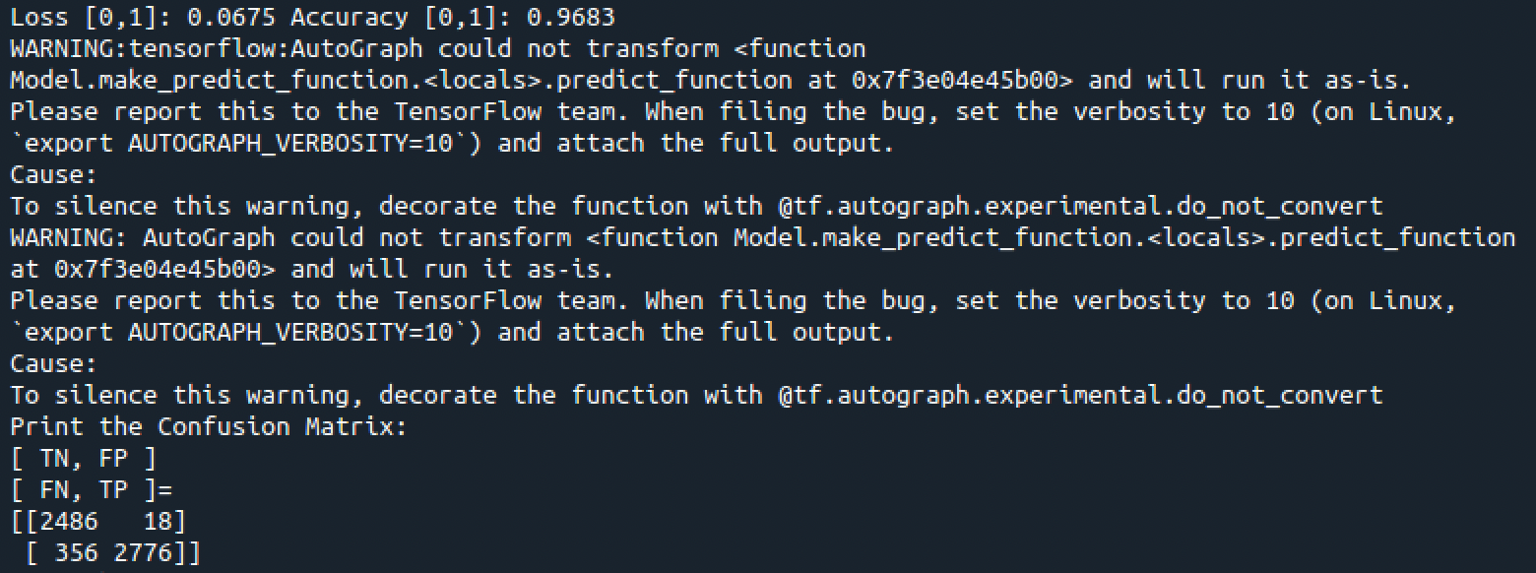

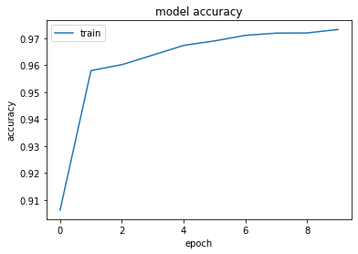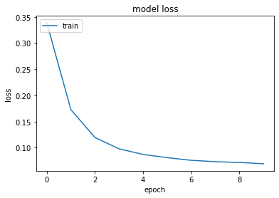

KDDTest-21: Loss 0.1338, Accuracy: 0.9487

Confusion Matrix: TN=550, FP=16, FN=342, TP=2055

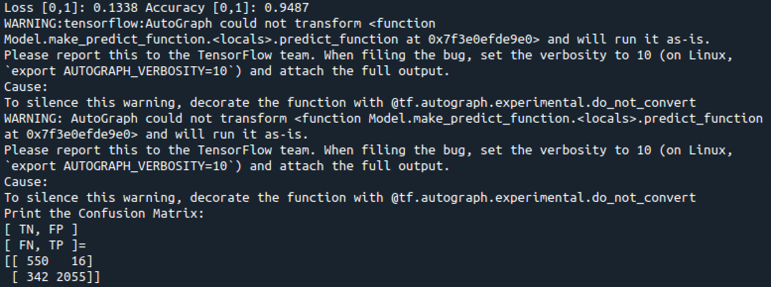

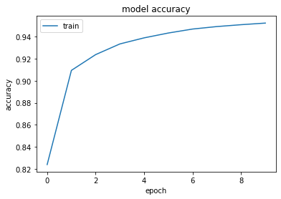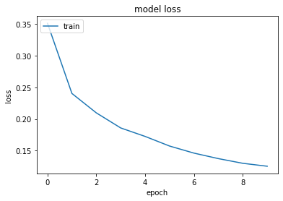

### Comparing the datasets:

In this case, the training set has even a bigger difference against the test data, since the latter have the most difficult traffic record (score of 21) excluded from the training, which means it has less quality input to train with.

Again, the training dataset provides more accuracy and less loss since it has a bigger set of data.

In this case a training dataset provides more accuracy and less loss since the test is smaller.

In this case a much bigger dataset (KDDTrain+) provides a superior accuracy and minor loss.

**KDDTrain+_20Percent.txt vs. KDDTest-21.txt**

KDDTrain+: Loss 0.0221, Accuracy: 0.9912

Confusion Matrix: TN=16806, FP=20, FN=533, TP=14135

KDDTest-21: Loss 0.1338, Accuracy: 0.9487

Confusion Matrix: TN=550, FP=16, FN=342, TP=2055

**KDDTrain+.txt vs. KDDTest+.txt**

KDDTrain+: Loss 0.0221, Accuracy: 0.9912

Confusion Matrix: TN=16806, FP=20, FN=533, TP=14135

KDDTest+: Loss 0.0675, Accuracy: 0.9683

Confusion Matrix: TN=2486, FP=18, FN=356, TP=2776

**KDDTest+.txt vs. KDDTrain+_20Percent.txt**

KDDTest+: Loss 0.0675, Accuracy: 0.9683

Confusion Matrix: TN=2486, FP=18, FN=356, TP=2776

KDDTrain+20Percent: Loss 0.0319, Accuracy: 0.9835

Confusion Matrix: TN=3386, FP=1, FN=174, TP=2737

**KDDTrain+.txt vs. KDDTrain+_20Percent.txt**

KDDTrain+: Loss 0.0221, Accuracy: 0.9912

Confusion Matrix: TN=16806, FP=20, FN=533, TP=14135

KDDTrain+20Percent: Loss 0.0319, Accuracy: 0.9835

Confusion Matrix: TN=3386, FP=1, FN=174, TP=2737

## Run the provided fnn sample.py python program with different one NSL-KDD dataset: KD- DTrain+.txt as the input and compare their detection accuracy with a different neural network setup. Explain your observations.

The fnn_sample.py has been modified as required, as shown below.



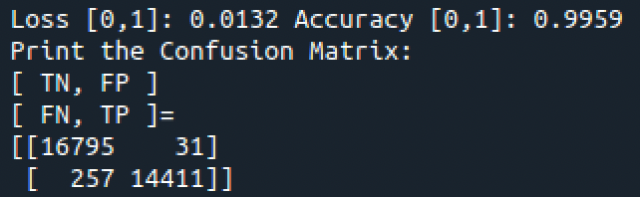

An increased depth of the FNN and increased epoch increases accuracy and reduces loss. While TN and FP increased, the FP and FN together diminished. Not all results improved.

An FNN model is used in the second section to create an anomaly detection model for network intrusion.

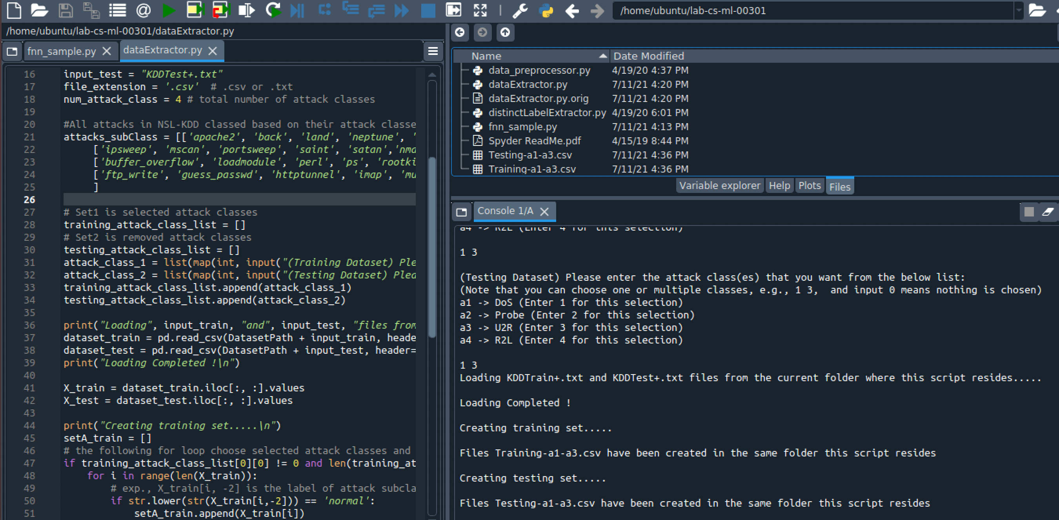

Using dataextractor.py

Results from the 3 wcenarios : accuracy shown in Python is the accuracy of the training model which is (TP + TN)/ (TN + FP + FN + TP)

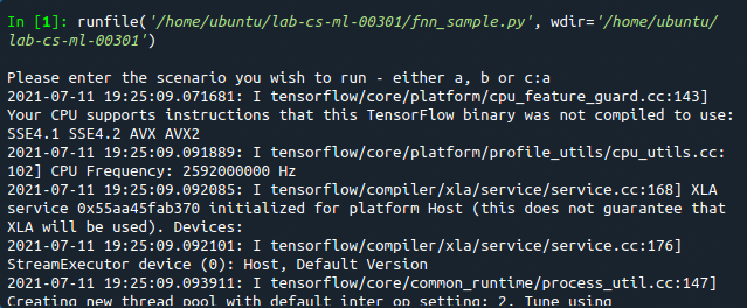

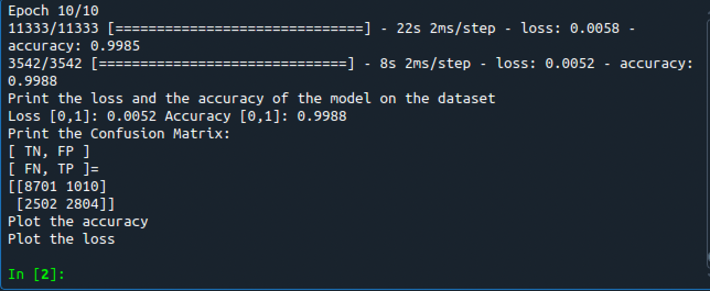

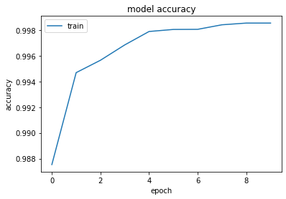

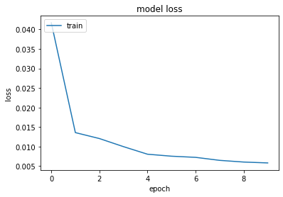

We use DoS and U2R as training and probing and R2L is the scenario that is the worst performing of the 3.

In terms of the confusion matrix.

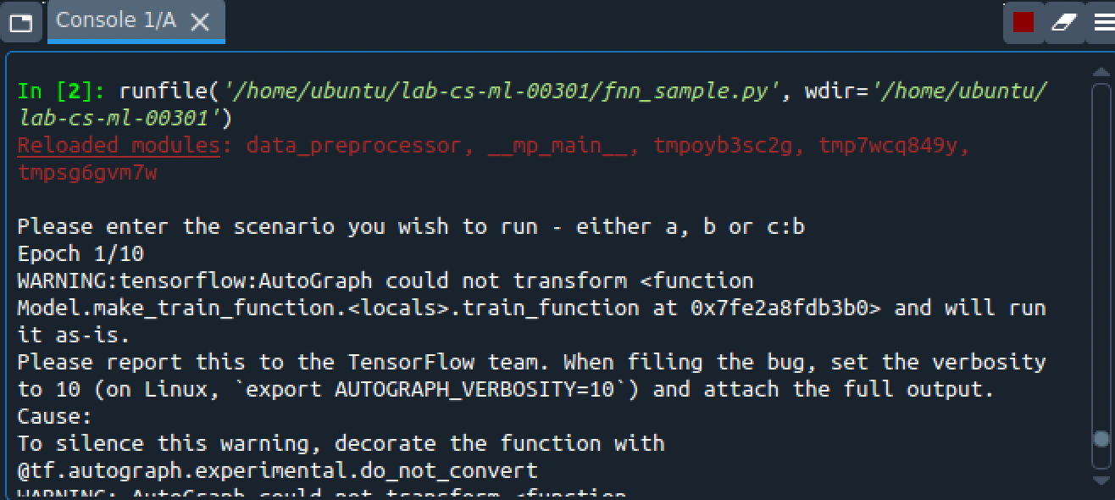

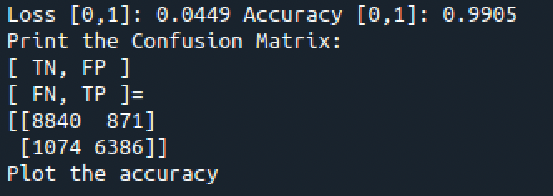

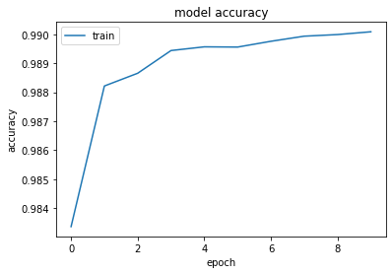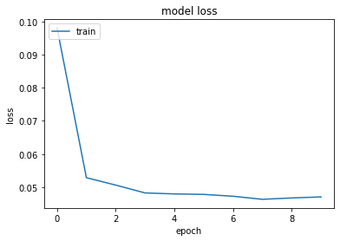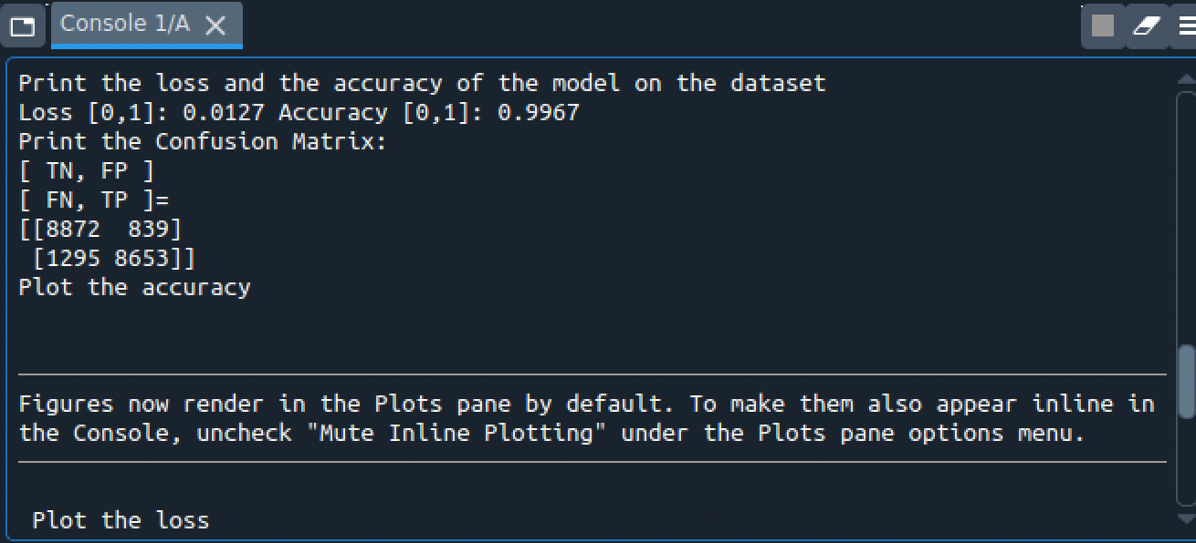

# Chart, line chart Description automatically generatedDoS and probe are testing in this scenarios

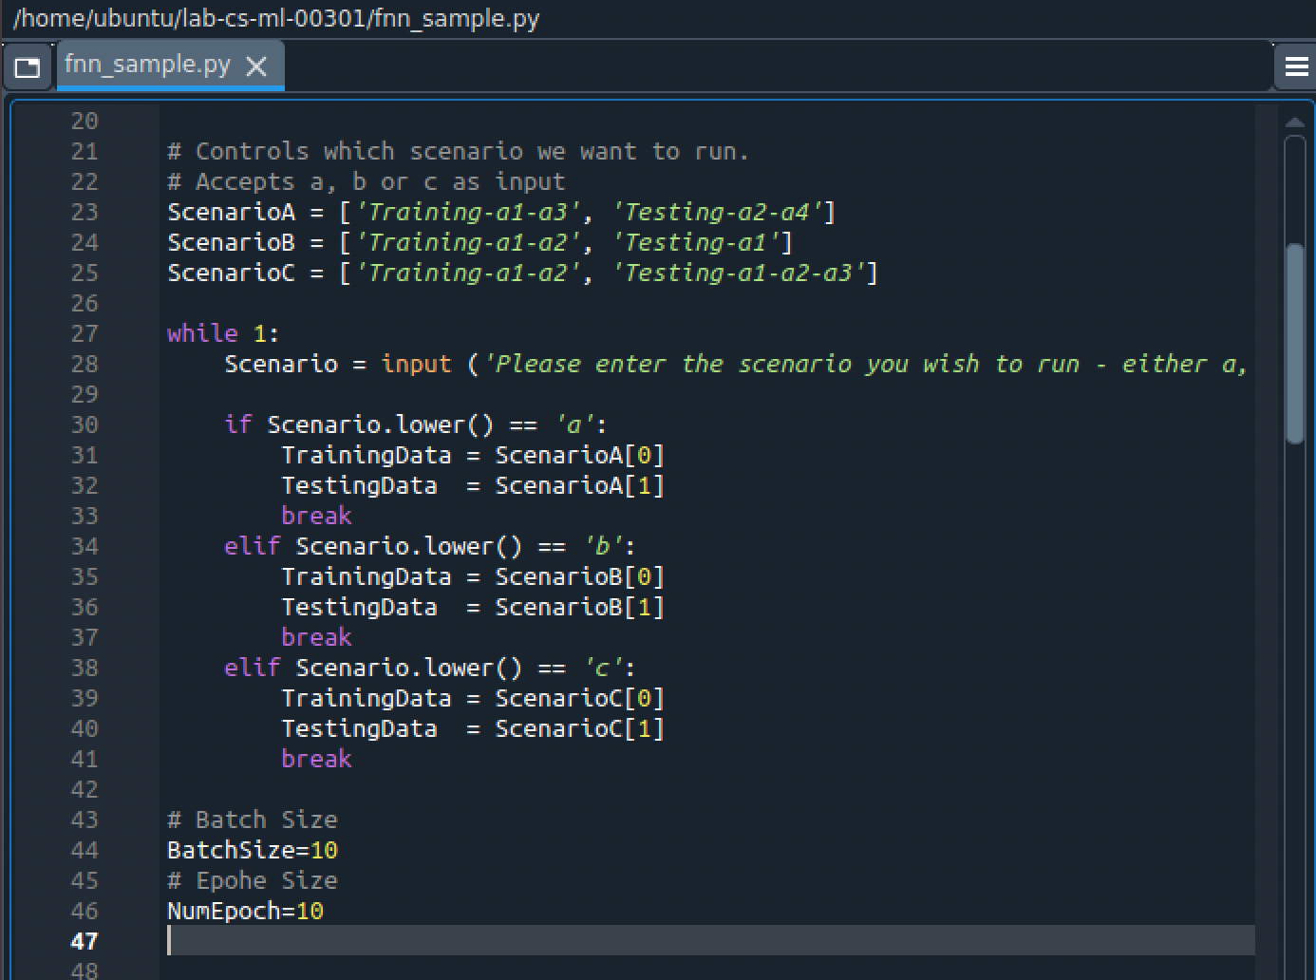

From line 56 up to the implementation of the FNN, I have implemented the code that loads the two pre-processed set (training and test) a

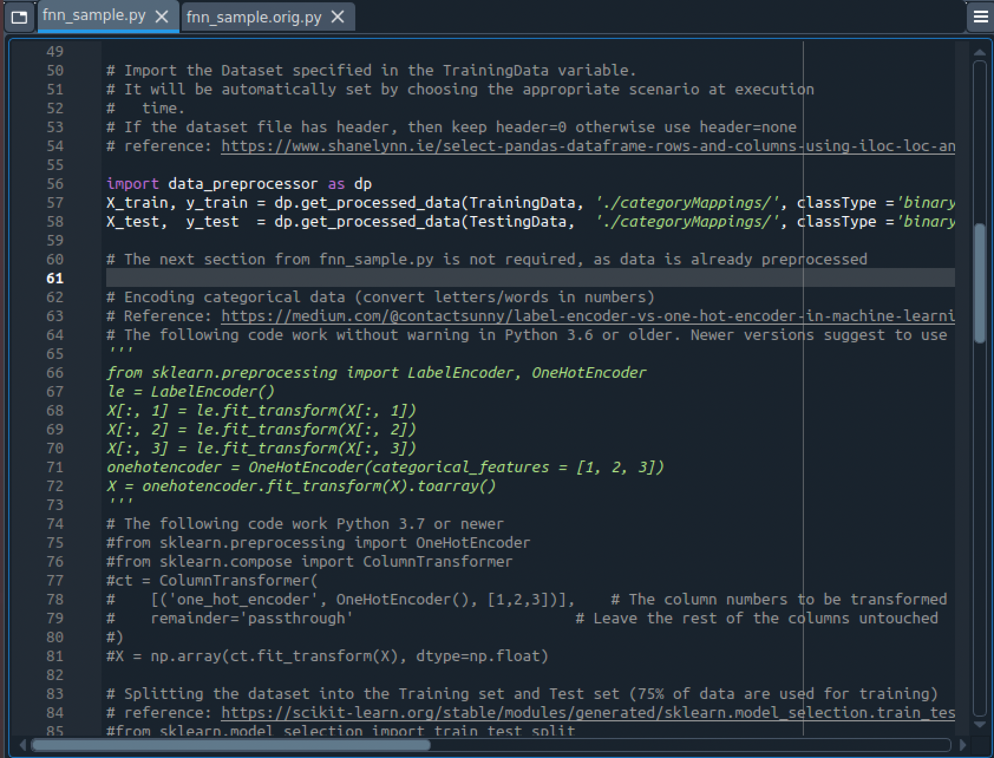

Scenario produces best results is scenario C. Best results are DoS and probe rather than DoS and U2R Probe is larger than U2R Catching probe attacks yields better outcomes than U2R attacks

Average accuracy between Scenario A, B, and C is 0.8481. Scenario A and C together is 0.8288. When attacks are present for the FNN which is not trained the performance is inferior.

When a scenario is presented with attacks , It performs worst in terms of accuracy.

The R2L and U2L are similar example the TCP protocol , must deposit a root transported via HTTP.

U2R and R2: are inferior to DoS and probe attacks.

# Appendix B: Attached files

See <https://github.com/anirudhk3/Project-4> for all files

# References

Linux NAT Tutorial: https://www.karlrupp.net/en/computer/nat_tutorial

• Ubuntu “Basic Iptables HOWTO”: https://help.ubuntu.com/community/IptablesHowTo

• “Iptables Tutorial: Ultimate Guide to Linux Firewall”: <https://phoenixnap.com/kb/iptables-tutorial-linux-firewall>

* <https://scikit-learn.org/stable/modules/generated/sklearn.model_selection.train_test_split.html>
* <https://scikit-learn.org/stable/modules/preprocessing.html>

Build ANN:

* <https://machinelearningmastery.com/tutorial-first-neural-network-python-keras/>
* <https://machinelearningmastery.com/rectified-linear-activation-function-for-deep-learning-neural-networks/>
* <https://machinelearningmastery.com/adam-optimization-algorithm-for-deep-learning/>
* <https://machinelearningmastery.com/how-to-choose-loss-functions-when-training-deep-learning-neural-networks/>